7 August, 2023

**PRESS RELEASE**

###### INFOGRAPHIC: PUBLIC FINANCE 2022

The Statistical Service (CYSTAT) publishes an Infographic on “[Public Finance 2022](https://www.cystat.gov.cy/en/Infographics/)”. The preliminary results of the General Government for the year 2022, which were published from CYSTAT on the 21/04/2023, indicate a fiscal surplus of €570,2 mn (2,1% of GDP) and a consolidated gross debt of €23.371,1 mn (86,5% of GDP).

During the year 2022, total revenue amounted to €11.321,5 mn and the main categories were taxes on production and imports (35,0%), social contributions (27,5%) and current taxes on income and wealth (25,4%).

During the year 2022, total expenditure amounted to €10.751,3 mn and the main categories were social benefits (39,3%), compensation of employees (29,4%) and intermediate consumption (11,4%).

The preliminary fiscal results for 2022 have been audited and verified within the Excessive Deficit Procedure framework of the European Commission.

[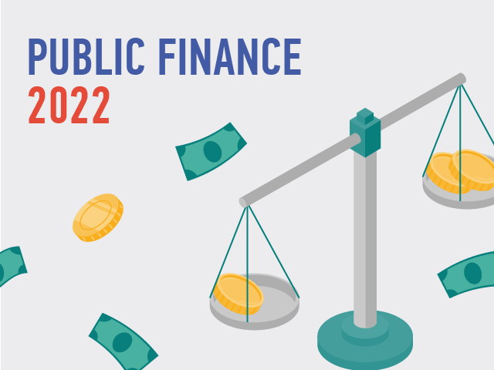](https://www.cystat.gov.cy/en/Infographics/)

***For more information:***

CYSTAT Portal, subtheme [Public Finance](https://www.cystat.gov.cy/en/SubthemeStatistics?id=48)

[CYSTAT-DB](https://cystatdb.cystat.gov.cy/pxweb/en/8.CYSTAT-DB/8.CYSTAT-DB__Public%20Finance__) (Online Database)

[Predefined Tables](https://www.cystat.gov.cy/en/KeyFiguresList?s=48) (Excel)

*Contact*

Michael Panayiota: Τel: +35722602186, Email: [pmichael@cystat.mof.gov.cy](mailto:pmichael@cystat.mof.gov.cy)